Algorithms to revise from tushar roy.

1. topographic sort
2. djikstra’s shortest path between on one Node to All
3. kruskal’s minimum spanning tree
4. prim’s is similar to djikstra but solve different problems.

NP: problems that are verifiable in polynomial time

NP-complete: problem is in np and is as hard as any problem in np.

Interval Scheduling problem:

greedy:
correct ans is choose the request which has earliest finish time. *will always give the correct ans
we can also prove above solution is correct by mathematical induction.

Convex hull problem: read from mit algorithm lecture 2.
it can be found by selecting the lines which can separate all points in one side and none point in other side. Choose that as a segment(o(n3) . Their is a better solution explained(nlogn).

Matrix multiplication stranssen method:
big formula

master’s theorem formula:

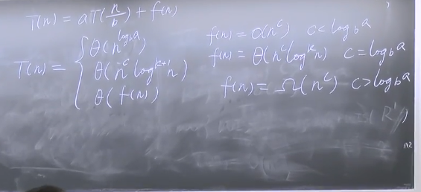

Amortized analysis:
aggregate method:

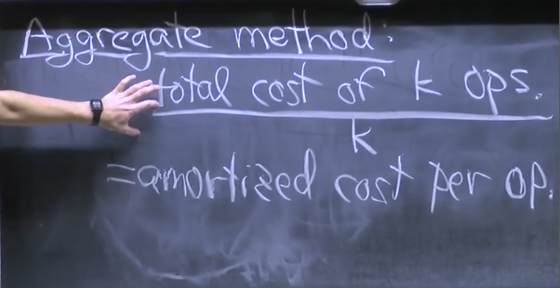

randomization:

matrix multiply- fredvald’s algorithm to check the correctness of matrix multiplication in order of (O(n2)) using a vector column.

Randomized Quicksort: worst case o(n2)

